Table of Contents
Catalog
Table of Contents 1
Read Me 2
Part 1:Setup & Overview 3
Part 2: Configuration & Settings Overview 5
Part 3: Submitting Test Tickets 9
Part 4: Help Desk Technician Guide 13
Part 5: Help Desk & Ticket Management Cheat Sheet 16
Part 6: Wrap-Up & Key Takeaways 18

Read Me

Overview
This project provides a complete guide to setting up, configuring, and managing a cloud-based help desk system using platforms like Freshdesk or Spiceworks. It simulates a real IT support environment, allowing users to experience the full lifecycle of ticket management, from creation to resolution, while applying best practices for troubleshooting, communication, and escalation.
The project covers creating a help desk account, configuring company profiles, adding agents and users, defining ticket categories, priorities, and custom attributes, and testing ticket submission via email, user portal, and manual entry. It also includes managing tickets efficiently using dashboards, applying automated ticket rules, documenting actions, and generating reports to monitor performance and trends.

Goals & Objectives
The goal of this project is to build a fully functional help desk environment while developing practical IT support expertise and demonstrating technical skills relevant to real-world IT operations. The objectives are to:
- Configure and manage a help desk system, including company profiles, users, agents, ticket categories, priorities, custom attributes, and automated ticket rules.
- Understand and apply ticket workflows, statuses, and prioritization to maintain efficient and organized support operations.
- Troubleshoot technical issues across hardware, software, network, and account/access domains, using systematic diagnostic methods and escalation procedures when necessary.
- Gain hands-on experience with technical tools such as cloud-based ticketing platforms, dashboards, reporting systems, email integrations, and workflow automation.
- Communicate effectively with users, document all actions accurately, and utilize knowledge bases and internal notes to support technical resolution.
- Monitor system performance, analyze ticket trends, generate actionable reports, and implement continuous process improvements.
This project serves as a hands-on learning experience and professional reference guide, highlighting technical skills and operational knowledge required for efficient, structured, and high-performing IT help desk operations.

Part 1:Setup & Overview
In this part, we’re setting up a working ticketing system environment. This includes creating your account, configuring the company profile, adding agents, defining ticket categories and statuses, and adding sample users. By the end, the system will be ready to simulate real IT support workflows.

Step 1: Create a Free Account
- Go to Freshdesk (or Spiceworks Cloud Help Desk).
- Sign up for the free plan.
- Note the portal URL (e.g., yourname.freshdesk.com).
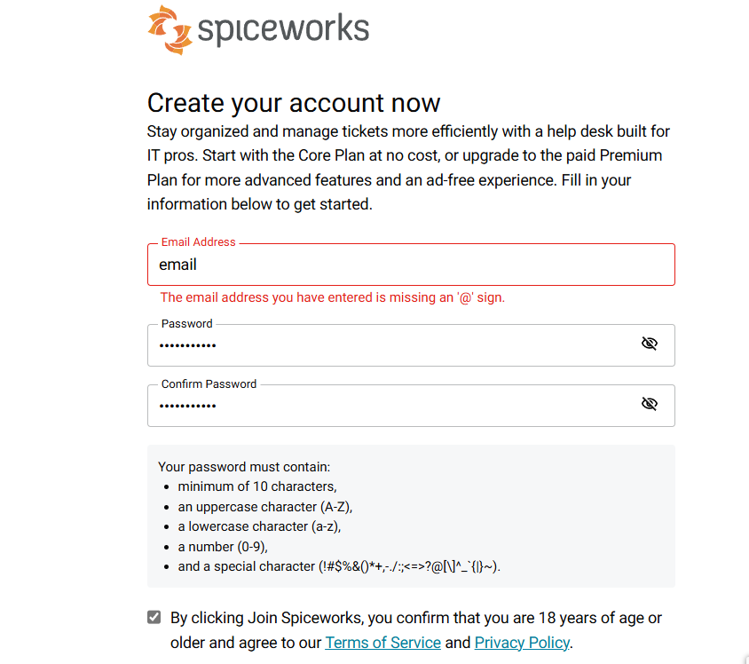

Step 2: Set Up Company Profile
- Add your company name.
- Optionally upload a logo.
- Configure the support email address.
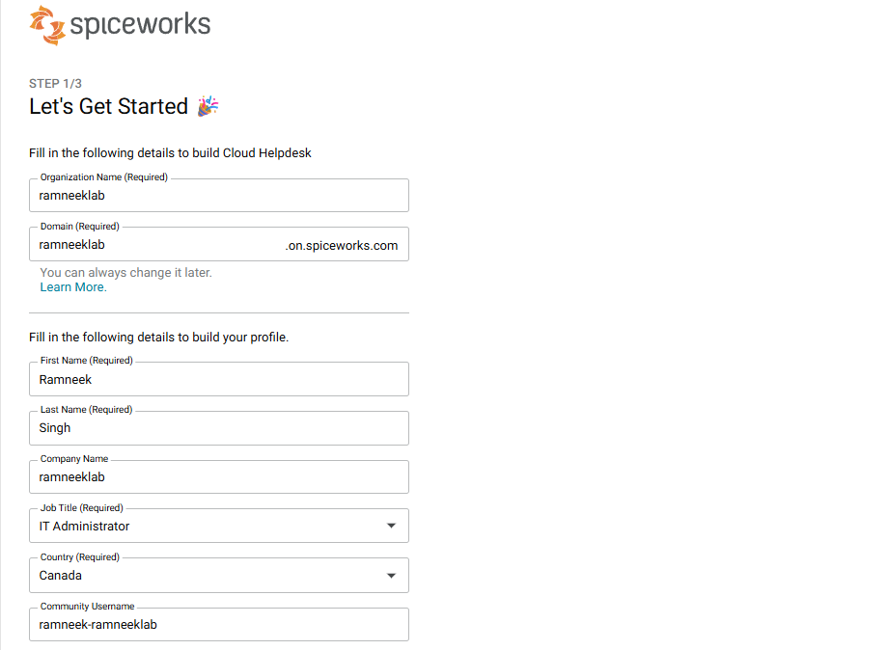
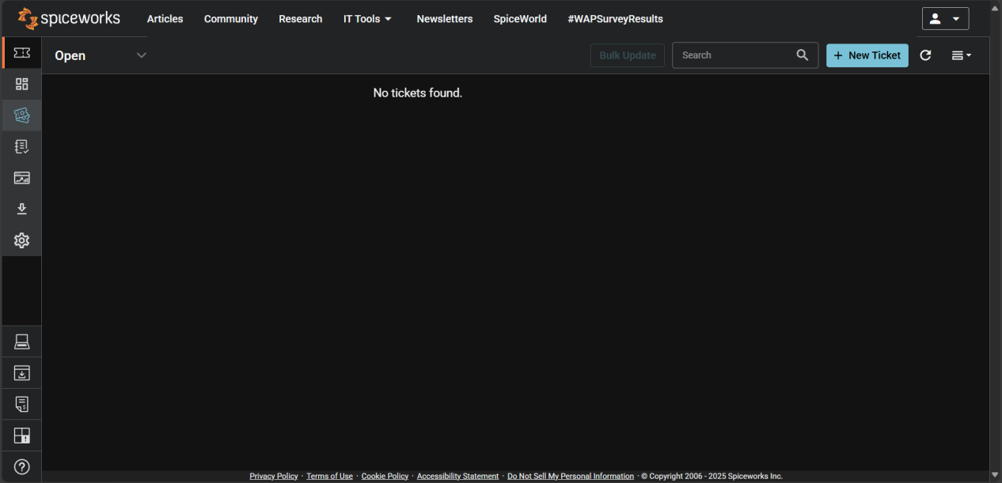

Part 2: Configuration & Settings Overview
This section explores the essential configuration options that define how your help desk operates.

Step 1: Ticket Rules

- Go to Settings → Tciket Rules.
- Create a rule to automatically route or categorize tickets. Example:
- If the subject contains “password,” assign to the IT Support technician.
- If the ticket is from a specific domain (e.g., @ramneeklab.com), mark as “High Priority.”
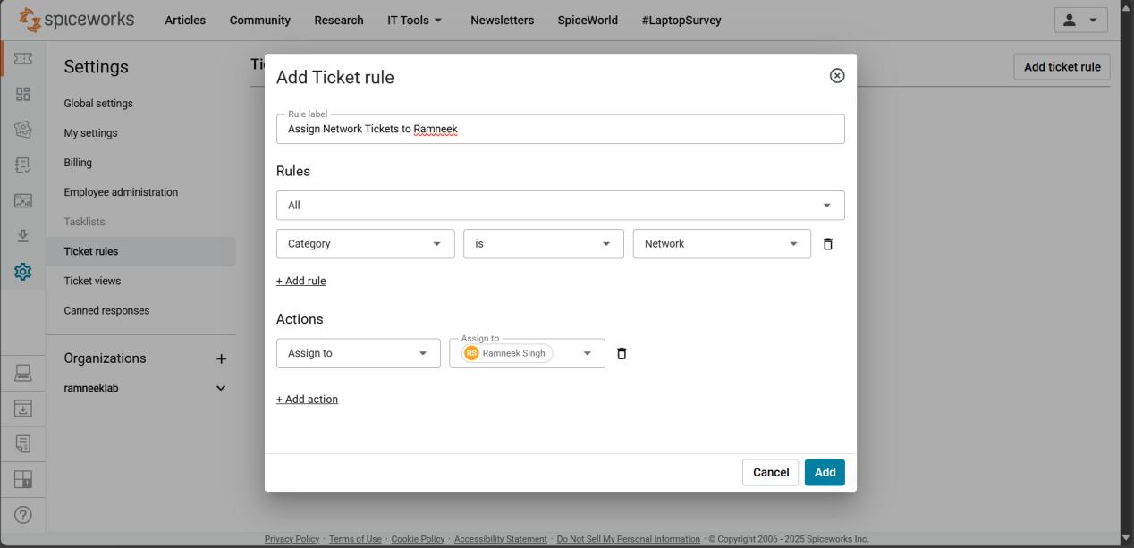

Step 2: Review Other Settings
- Navigate through the following key areas to understand what they do:
- Organizations: Basic info about your company (RamneekLab).
- General: Adjust system defaults such as notifications and display preferences.
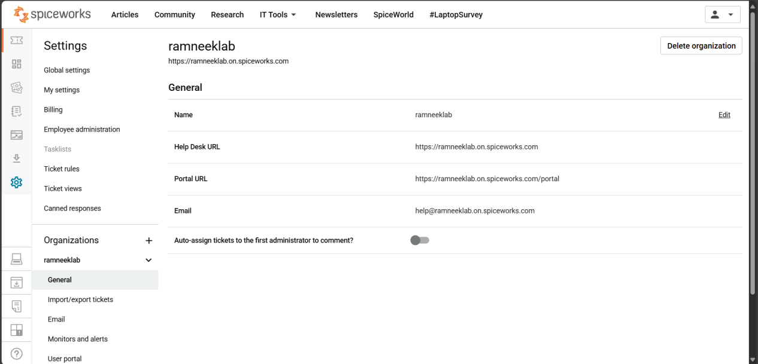
- Import/Export Tickets: Useful for backing up or migrating ticket data.
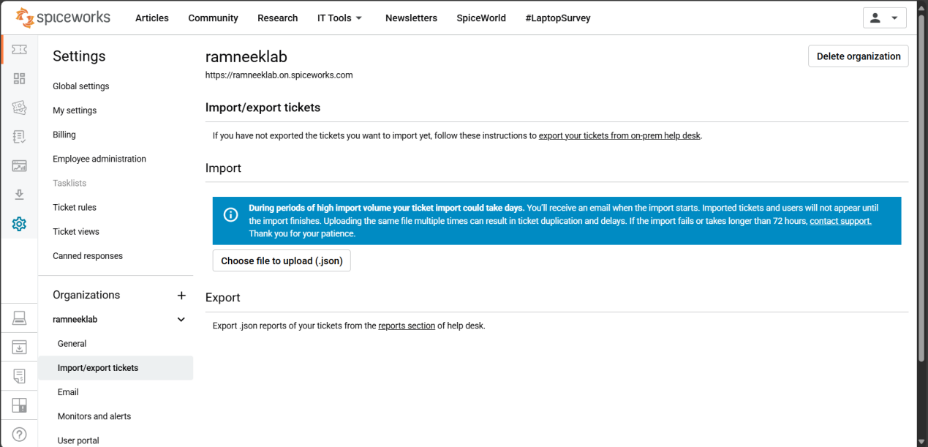
- Email: Configure your support email (e.g., support@ramneeklab.com). This allows users to email directly to create tickets.
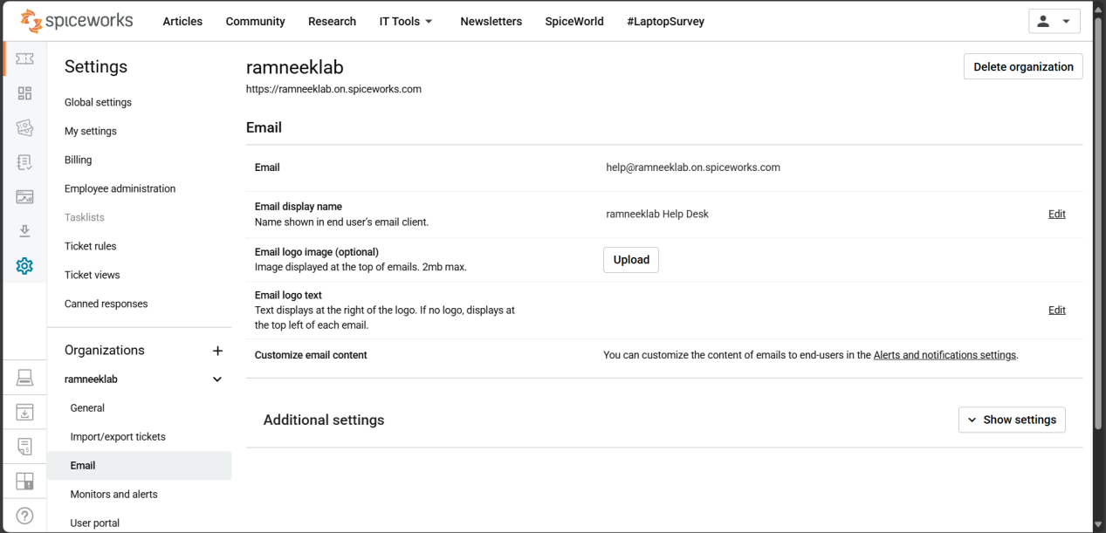
- Monitors and Alerts: Set alerts for new or overdue tickets.
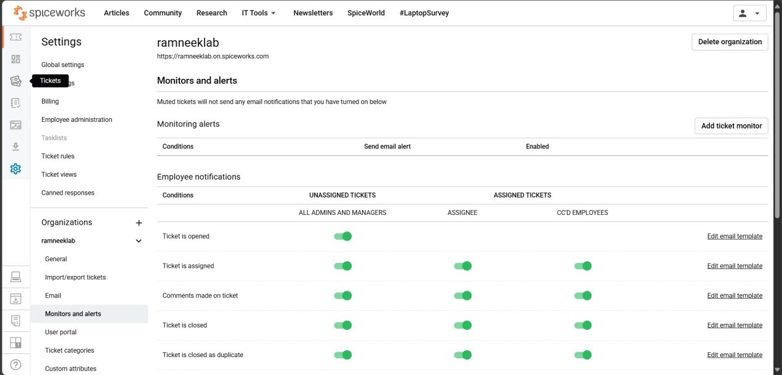
- User Portal: Customize how your users submit and track their requests online.
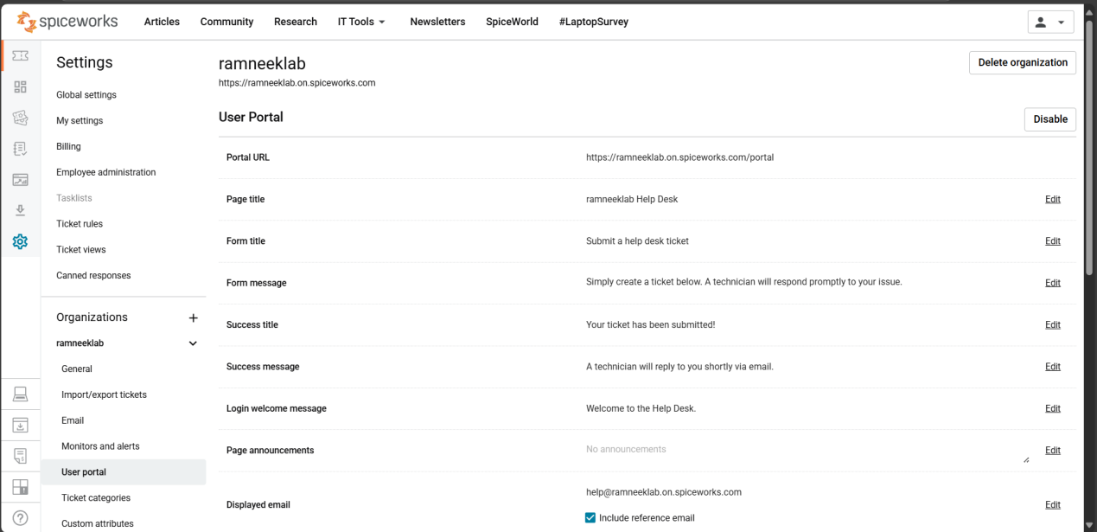
- Ticket Categories: Organize issues into categories like Hardware, Software, Network, etc.
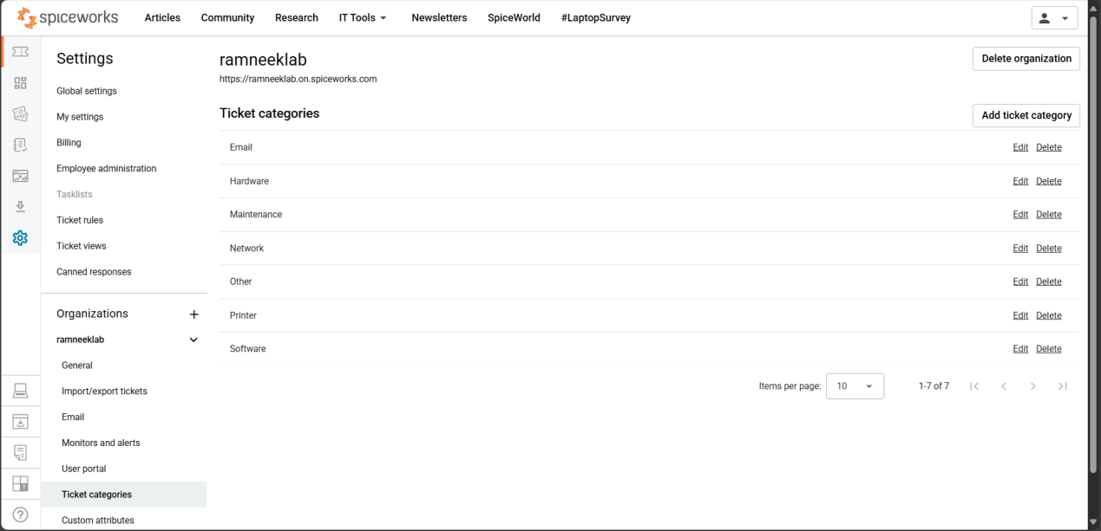
- Custom Attributes: Add extra fields to tickets if needed (e.g., “Department” or “Device Type”).
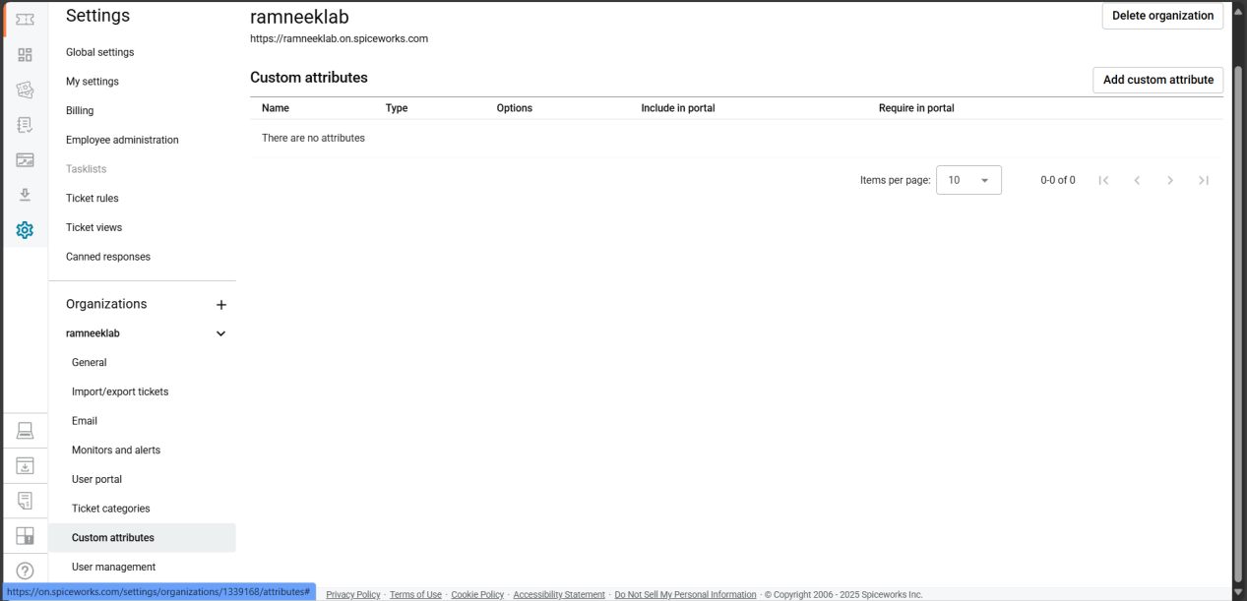
- User Management: View and manage the list of technicians and users who interact with the help desk.
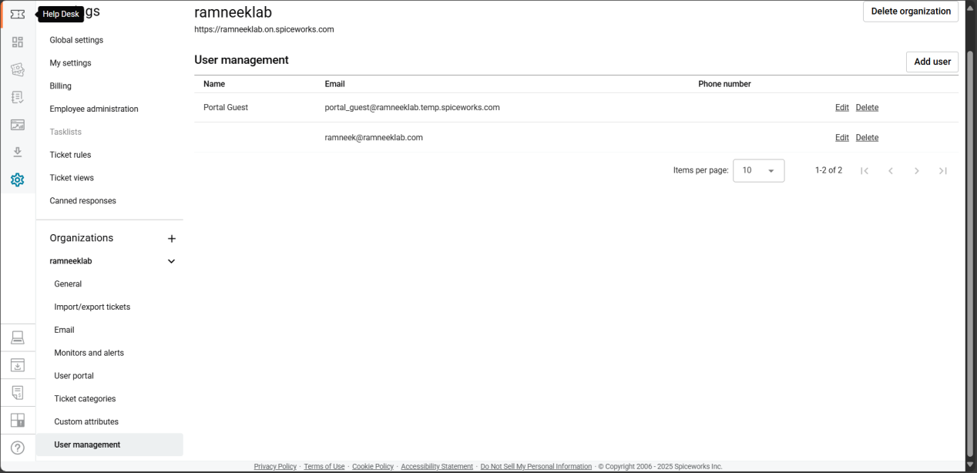
- This section ensures you understand how each part contributes to a smooth ticketing workflow.

Part 3: Submitting Test Tickets

Now that your help desk is configured, it’s time to test different ways users can submit tickets.

Method 1: Email Submission
- Send an email to your support address (example: support@ramneeklab.com).
- The system will automatically generate a ticket.
- Example subject lines:
  - “Laptop won’t boot”
  - “Need access to shared drive”
  - “Wi-Fi not working in lab”
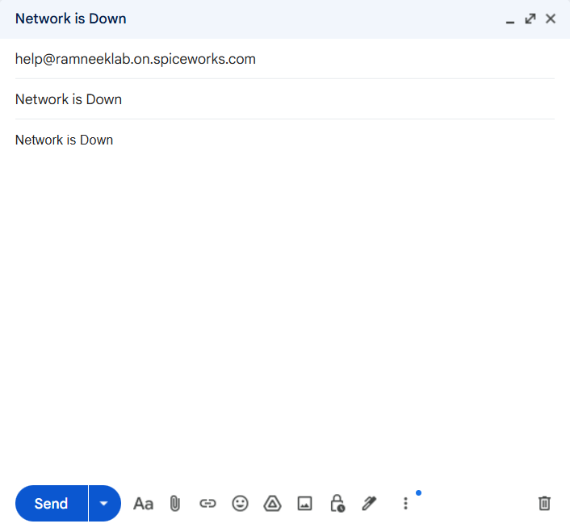
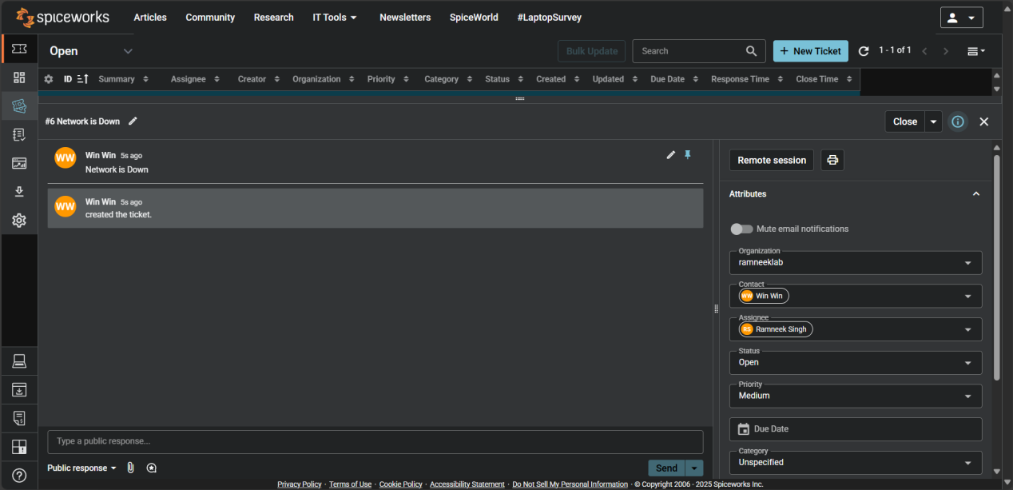
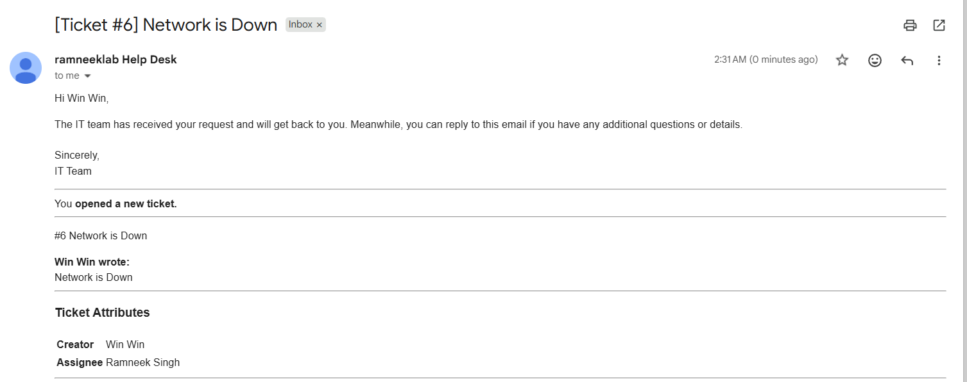
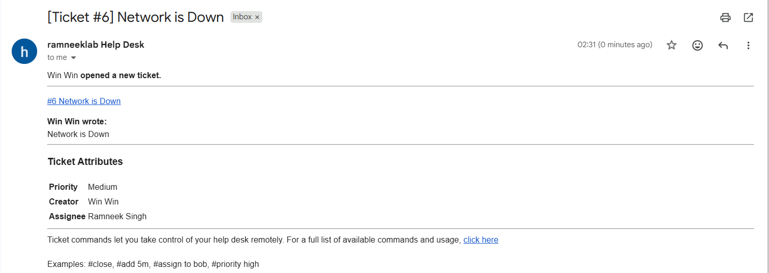

Method 2: User Portal Submission
- Visit your help desk portal (e.g., ramneeklab.spiceworks.helpdesk.com/portal).
- Users can fill out a short form with subject, description, and category.
- The ticket will appear in the dashboard instantly.
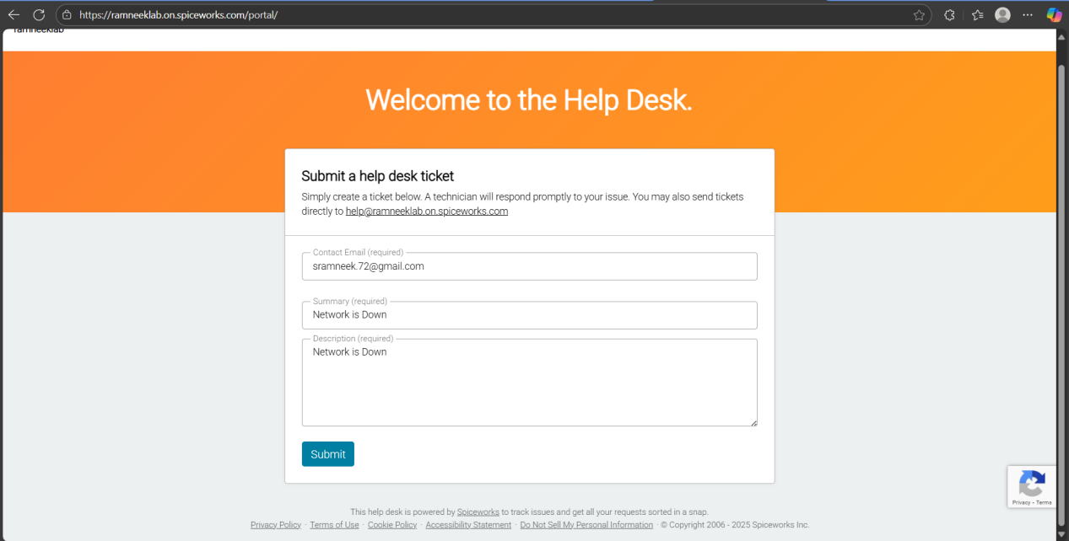
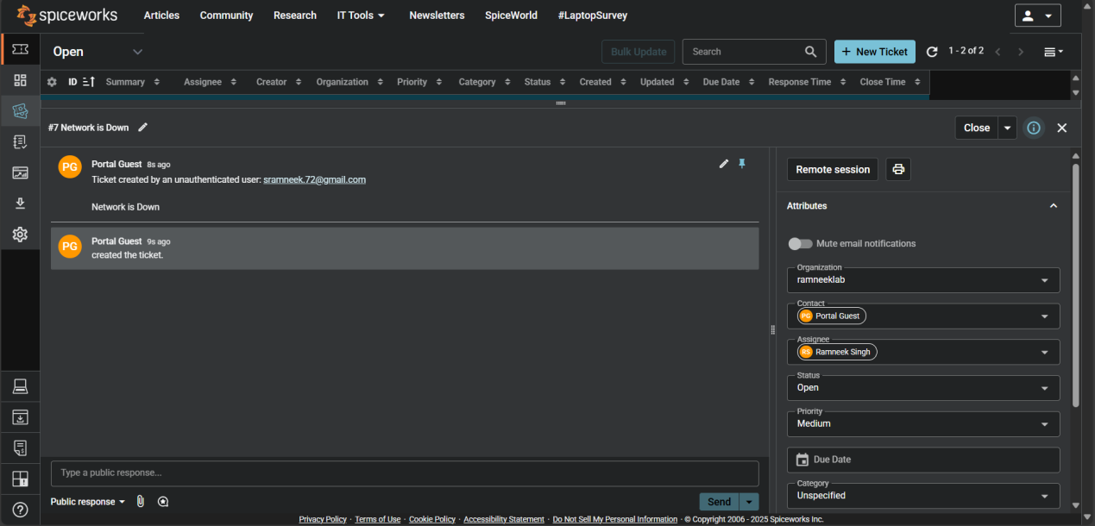

Method 3: Manual Ticket Creation (Technician)
- From your dashboard, click New Ticket.
- Enter the requester’s name, issue details, and category.
- Save the ticket — this is useful when a user calls or messages you directly.
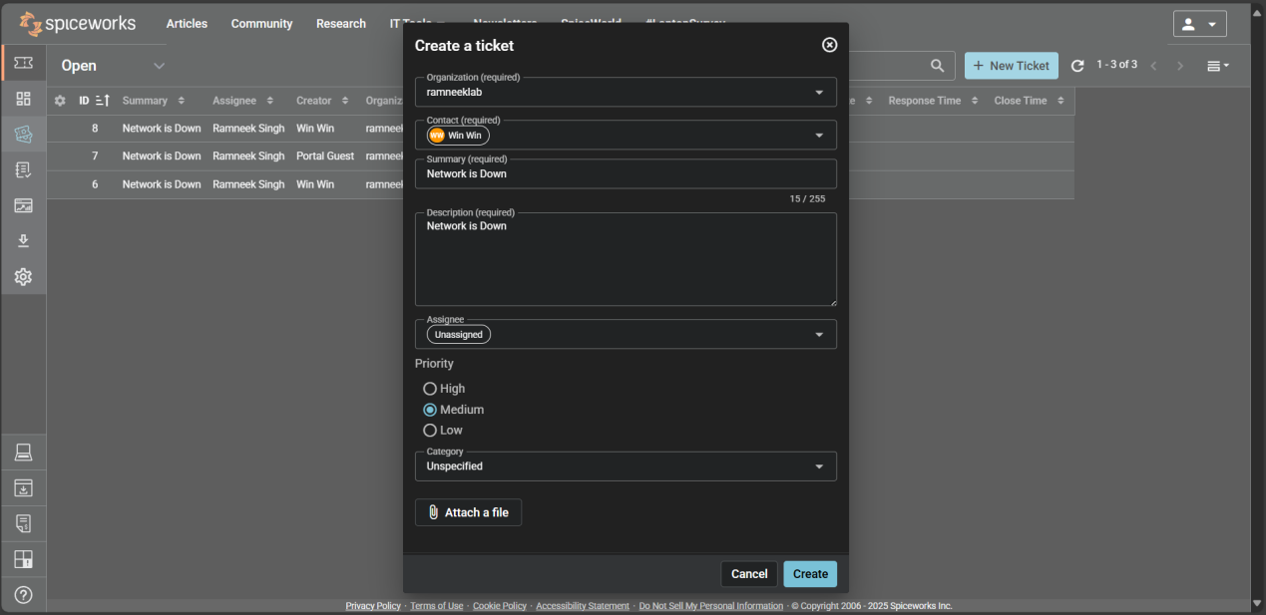
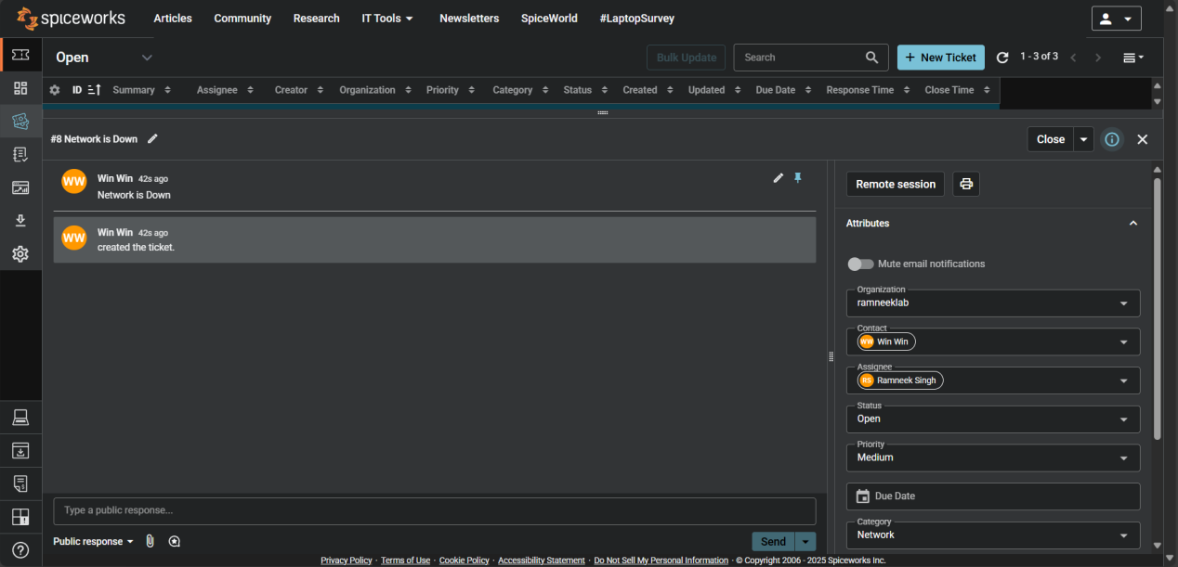

Part 4: Help Desk Technician Guide

This section focuses on how to manage tickets effectively as a help desk technician. You’ll learn the full workflow from ticket creation to resolution.

Step 1: Reviewing and Assigning Tickets
- Open the Tickets tab on your dashboard.
- Click on a ticket to view details.
- Assign it to yourself or another technician if applicable.
- Check the category, priority, and requester info.
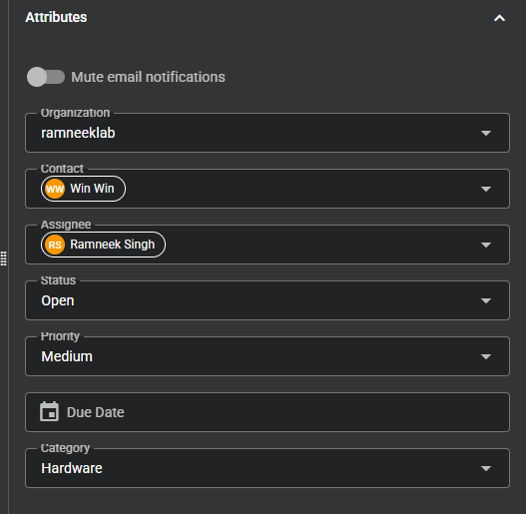

Step 2: Communicating with Users
- Use the Public Reply section to respond to users directly.
- Replies are automatically emailed to the requester.
- Use Private Notes for internal updates visible only to technicians.
- Add attachments or screenshots if needed.
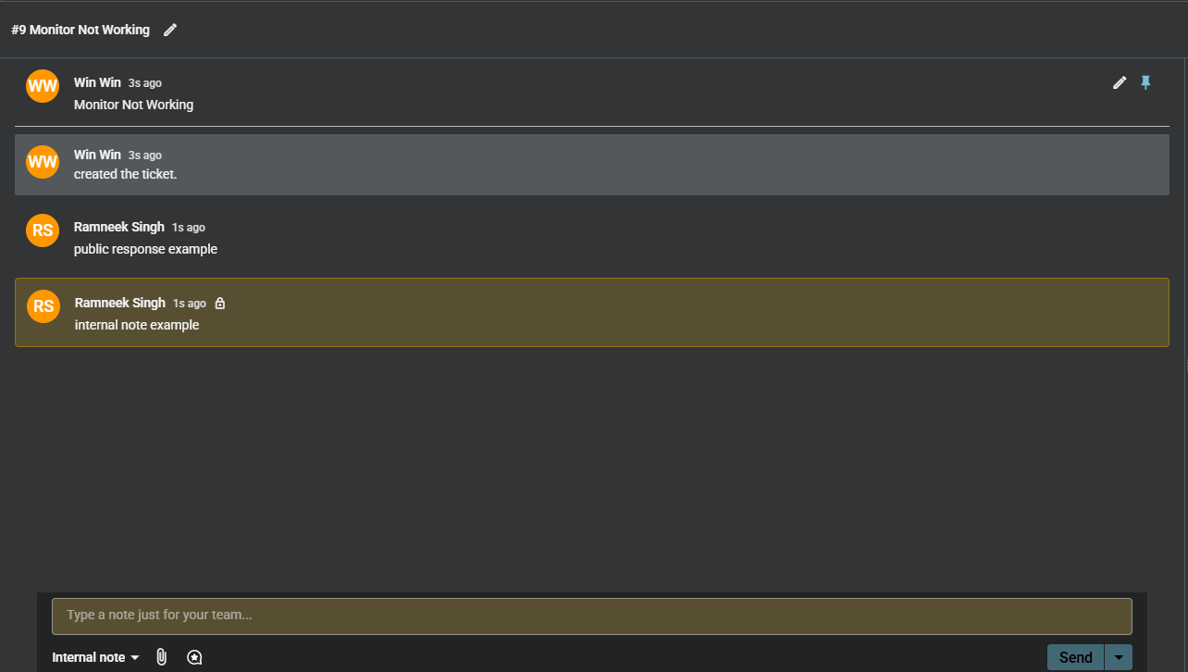

Step 3: Updating Ticket Status and Priority
- Change the ticket status depending on progress:
- Open – New ticket received.
- In Progress – Issue being worked on.
- On Hold – Waiting for user response or external action.
- Closed – Issue resolved.
- Adjust the priority (Low, Medium, High, Critical) based on urgency.
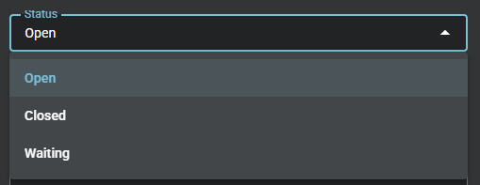
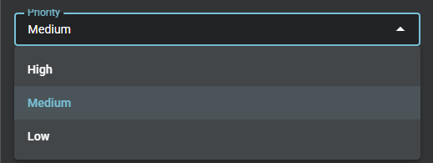

Step 4: Tracking and Reporting
- Use the Dashboard to monitor open and closed tickets.
- Check response times and technician workloads.
- Use reports to analyze trends and common issues.
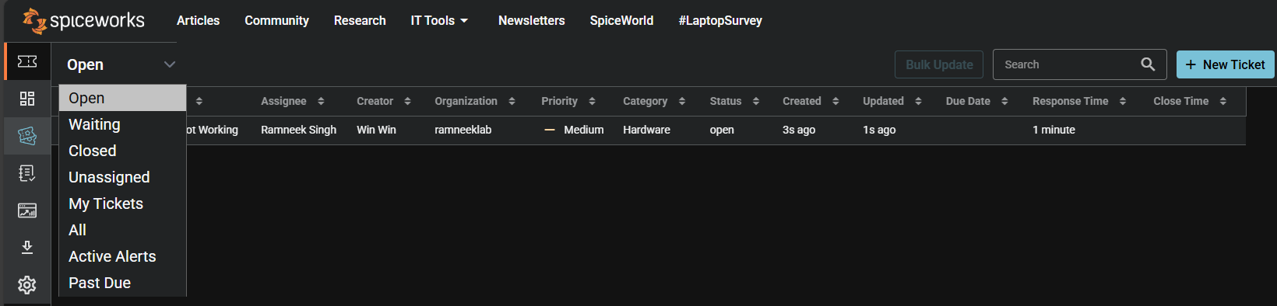
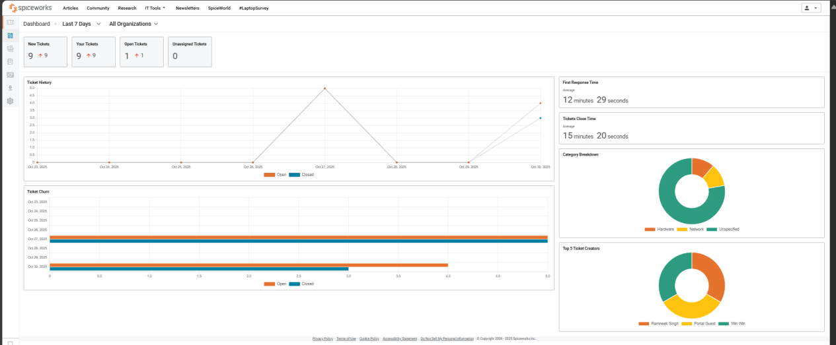

Part 5: Help Desk & Ticket Management Cheat Sheet
This section serves as a complete reference for managing tickets efficiently, troubleshooting common issues, communicating with users, and knowing when to escalate.

1. Ticket Workflow & Status
- Open: New ticket received; needs acknowledgment.
- In Progress: Technician is actively working on the issue.
- On Hold: Waiting for user input or external action.
- Closed: Issue resolved and confirmed.

2. Ticket Priorities
- Low: Minor issue, no significant impact.
- Medium: Moderate impact, some disruption.
- High: Major issue affecting important functions.
- Critical: System-wide outage or urgent problem.

3. Initial Ticket Check
- Read the ticket fully: subject, description, attachments.
- Identify category (Hardware, Software, Network, Access, etc.) and priority.
- Search the knowledge base for similar resolved issues.
- Confirm requester's contact info and urgency.

4. Troubleshooting Steps by Problem Type
- Hardware Issues
  - Check power supply, cables, and connections.
  - Restart the device and peripherals.
  - Test with known-working components if possible.
  - Escalate if the device is dead, physically damaged, or repair is beyond your level.
- Software Issues
  - Restart the program or device.
  - Check for software updates or patches.
  - Reinstall or reset the application if needed.
  - Escalate if it's a system-wide bug, license issue, or complex configuration problem.
- Network Issues
  - Verify connectivity: Wi-Fi, Ethernet, VPN.
  - Test IP, DNS, and ping the server.
  - Restart network devices (modem, router, switch).
  - Escalate if multiple users are affected, or if the issue is external/provider-related.
- Account/Access Issues
  - Reset passwords or unlock accounts.
  - Verify permissions, group membership, or license allocation.
  - Escalate if admin-level changes, security concerns, or policy conflicts arise.

5. Communication Best Practices
- Acknowledge tickets promptly; even a short confirmation improves user satisfaction.
- Use clear, concise, and professional language; avoid technical jargon with non-technical users.
- Provide step-by-step instructions when guiding users.
- Keep users updated on progress, delays, or escalations.
- Document all actions, decisions, and communications in the ticket.

6. When to Escalate
- Issue cannot be resolved with standard troubleshooting.
- Multiple users are affected or the problem has system-wide impact.
- Security-related concerns such as malware, unauthorized access, or data breaches.
- Hardware or software failures beyond technician authority.
- Requests outside your access or role (e.g., admin rights, sensitive data).

7. Resolution & Closure
- Confirm with the user that the issue is fully resolved.
- Update the ticket with detailed steps taken, resolution, and any follow-up notes.
- Close the ticket in the system using correct category and priority.
- Add recurring or unique solutions to the knowledge base for future reference.

8. Quick Reference Table
Problem Type | Quick Checks/Steps | Escalate When
Hardware | Power, cables, restart, peripherals | Device dead, physically damaged, repair needed
Software | Restart, update, reinstall | System-wide bug, license/config issue
Network | Ping, reconnect, router/modem restart | Multiple users affected, ISP/external issue
Account/Access | Reset password, check permissions | Admin-level changes, security concerns

9. Tips for Efficient Help Desk Management
- Monitor dashboards for overdue tickets.
- Reuse solutions/templates for common issues.
- Track trends via reports to improve processes.
- Organize tickets consistently using categories and priorities.
- Always maintain professionalism and patience, even with frustrated users.

Part 6: Wrap-Up & Key Takeaways
This final section summarizes the main points of the help desk project and reinforces the key lessons learned for efficient IT support management.

1. Setting Up Your Help Desk:
- Creating an account, configuring company profile, adding agents, and defining ticket categories are essential first steps.
- Proper setup ensures a structured workflow and avoids confusion during ticket handling.

2. Ticket Management Essentials:
- Understand ticket workflows (Open, In Progress, On Hold, Closed) and prioritize tickets according to impact.
- Use ticket rules, categories, and custom attributes to streamline operations.
- Test all submission methods (email, portal, manual) to confirm proper system function.

3. Troubleshooting & Escalation:
- Follow systematic troubleshooting based on problem type (Hardware, Software, Network, Account/Access).
- Escalate issues when they exceed technician authority, affect multiple users, or involve security concerns.
- Always document steps taken and communicate clearly with users.

4. Communication & Best Practices:
- Respond promptly and professionally.
- Keep users informed of progress, delays, or escalations.
- Maintain detailed records to support reporting, analysis, and knowledge sharing.

5. Efficiency & Continuous Improvement:
- Utilize automation, templates, and SLAs to save time.
- Monitor dashboards and reports to identify trends and optimize workflows.
- Maintain a knowledge base to reduce repeated issues and support user self-service.

6. Key Takeaways:
- A structured setup plus consistent workflow ensures effective ticket handling.
- Clear communication, proper documentation, and escalation rules improve user satisfaction.
- Monitoring metrics and continuously improving processes leads to a high-performing help desk.
- Combining technical troubleshooting with soft skills is essential for professional IT support.

